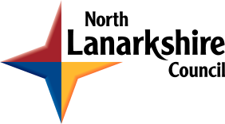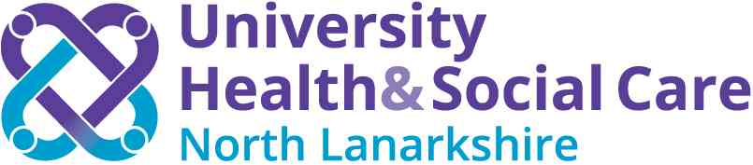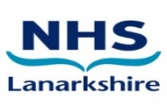
NORTH LANARKSHIRE INTEGRATION JOINT BOARD
ANNUAL ACCOUNTS 2023/24

Notice is hereby given, in terms of Section 101(1) of the Local Government (Scotland) Act 1973, and Regulation 9(1) of the Local Authority Accounts (Scotland) Regulations 2014 that:
An unaudited copy of the Accounts of North Lanarkshire Integration Joint Board for the year period from 1 April 2023 to 31 March 2024 will be available to view electronically from Friday 28 June 2024 at the following website: North Lanarkshire Health and Social Care Partnership (hscnl.org.uk)
The Annual Accounts will be open for inspection free of charge by any person interested, between Monday 1 July 2024 and Friday 19 July 2024 (inclusive). All such persons interested may inspect the unaudited accounts and all books, deeds, contracts, bills, vouchers, and receipts relating thereto and make copies of all or any part of the accounts and those other documents. This can be done in person during office hours, Monday to Friday or otherwise requested by email to IJBannualaccounts@northlan.gov.uk
Any person interested may make objections to the Accounts or any part thereof, together with a statement of the grounds of complaint, to the North Lanarkshire IJB’s auditor, Mr John Boyd, Audit Director, Audit Scotland by email to jboyd@audit-scotland.gov.uk
A copy of the objection and the statement should be sent to the Officer concerned and to the Chief Officer of North Lanarkshire Council IJB within 21 days of the Accounts being first available for public inspection. Any person who makes any such objection has the right to appear before and be heard by the Auditors, Audit Scotland, either personally or by a representative with respect to that objection. The format of any such hearing would be at the choice of the objector, either conducted in person or remotely using appropriate electronic communication.
Ross McGuffie
Chief Officer
North Lanarkshire Health and Social Care Partnership

